**1] write a java program to read and display the data in a file as output.**

package javaapplication1;

import java.io.File;

import java.io.FileNotFoundException;

import java.util.Scanner;

public class JavaApplication1 {

public static void main(String[] args) {

String filePath = "C:\\java programs\\sample.txt";

try {

File file = new File(filePath);

Scanner scanner = new Scanner(file);

while (scanner.hasNextLine()) {

String line = scanner.nextLine();

System.out.println(line);

}

scanner.close();

} catch (FileNotFoundException e) {

System.out.println("File not found: " + filePath);

}

}

}

**Output:**

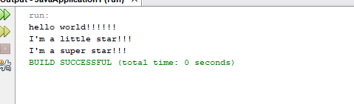

**2] Write a java program to read and display the data in a txt using get and set method**

package javaapplication3;

import java.io.BufferedReader;

import java.io.FileReader;

import java.io.IOException;

import java.util.ArrayList;

import java.util.List;

class CharacterData {

private char character;

public char getCharacter() {

return character;

}

public void setCharacter(char character) {

this.character = character;

}

}

public class JavaApplication3 {

public static void main(String[] args) {

ArrayList<CharacterData> characterList = new ArrayList<>();

try (BufferedReader br = new BufferedReader(new FileReader("C:\\java programs\\sample.txt"))) {

int character;

while ((character = br.read()) != -1) {

CharacterData data = new CharacterData();

data.setCharacter((char) character);

characterList.add(data);

}

} catch (IOException e) {

System.err.println("Error reading file: " + e.getMessage());

}

for (CharacterData data : characterList) {

System.out.print(data.getCharacter());

}

}

}

**Output:**

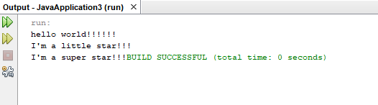

**3] write a program to write into a txt file.**

package javaapplication4;

import java.io.BufferedWriter;

import java.io.FileWriter;

import java.io.IOException;

import java.util.ArrayList;

public class JavaApplication4 {

public static void main(String[] args) {

ArrayList<String> listOfStrings = new ArrayList<>();

listOfStrings.add("I'm a collage student");

listOfStrings.add("I'm a BTech AIDS student");

try (BufferedWriter bw = new BufferedWriter(new FileWriter("C:\\java programs\\sample.txt"))) {

for (String str : listOfStrings) {

bw.write(str);

bw.newLine();

}

} catch (IOException e) {

System.err.println("Error writing file: " + e.getMessage());

}

System.out.println("Data written to file successfully!");

}

}

**Output:**

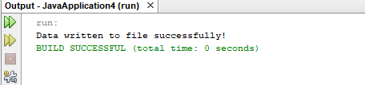

**4] write a java program to append a data to an existing file.**

package javaapplication5;

import java.io.BufferedWriter;

import java.io.FileWriter;

import java.io.IOException;

import java.util.ArrayList;

public class JavaApplication5 {

public static void main(String[] args) {

ArrayList<String> listOfStrings = new ArrayList<>();

listOfStrings.add("I'm a little star");

listOfStrings.add("I'm a super star");

try (BufferedWriter bw = new BufferedWriter(new FileWriter("C:/java programs/sample.txt", true))) {

for (String str : listOfStrings) {

bw.write(str);

bw.newLine();

}

} catch (IOException e) {

System.err.println("Error writing file: " + e.getMessage());

}

System.out.println("Data appended to file successfully!");

}

}

**Output:**

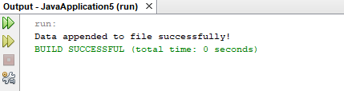

**5] Write a program to create an concrete class and get path of the file in different methods.**

package javaapplication6;

import java.io.File;

import java.nio.file.Path;

import java.nio.file.Paths;

public class JavaApplication6 {

private File file;

public JavaApplication6(String filePath) {

this.file = new File(filePath);

}

public String getAbsolutePath() {

return file.getAbsolutePath();

}

public String getCanonicalPath() {

try {

return file.getCanonicalPath();

} catch (Exception e) {

return "Error getting canonical path: " + e.getMessage();

}

}

public String getParent() {

return file.getParent();

}

public String getName() {

return file.getName();

}

public String getPath() {

return file.getPath();

}

public String getNormalizedPath() {

Path path = Paths.get(file.getAbsolutePath());

return path.normalize().toString();

}

public static void main(String[] args) {

JavaApplication6 filePath = new JavaApplication6("sample.txt");

System.out.println("Absolute Path: " + filePath.getAbsolutePath());

System.out.println("Canonical Path: " + filePath.getCanonicalPath());

System.out.println("Parent: " + filePath.getParent());

System.out.println("Name: " + filePath.getName());

System.out.println("Path: " + filePath.getPath());

System.out.println("Normalized Path: " + filePath.getNormalizedPath());

}

}

**Output:**

